## The SQL SELECT Statement

## Demo Database

SELECT * FROM Customers;

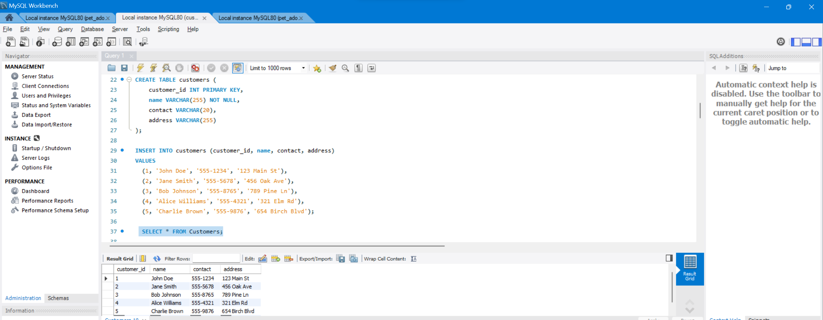

# **SQL SELECT DISTINCT Statement**

SELECT DISTINCT Names FROM Customers;

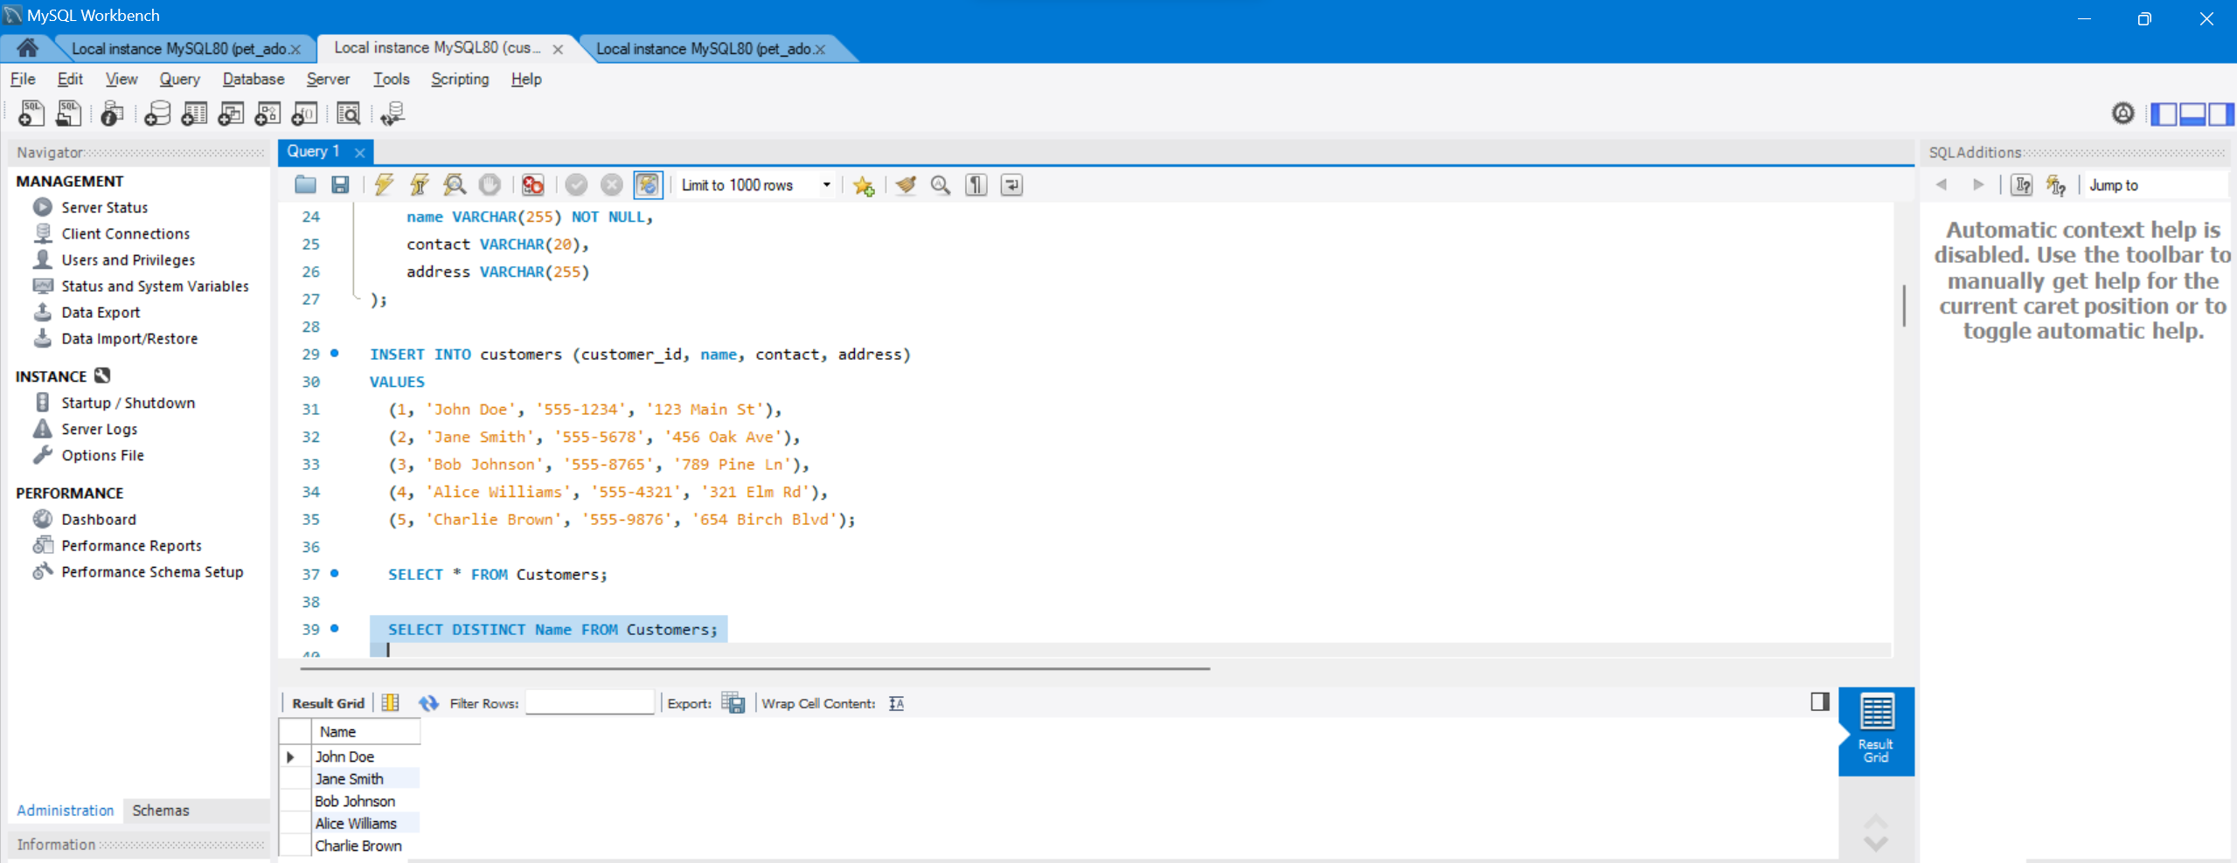

### Having Clause :

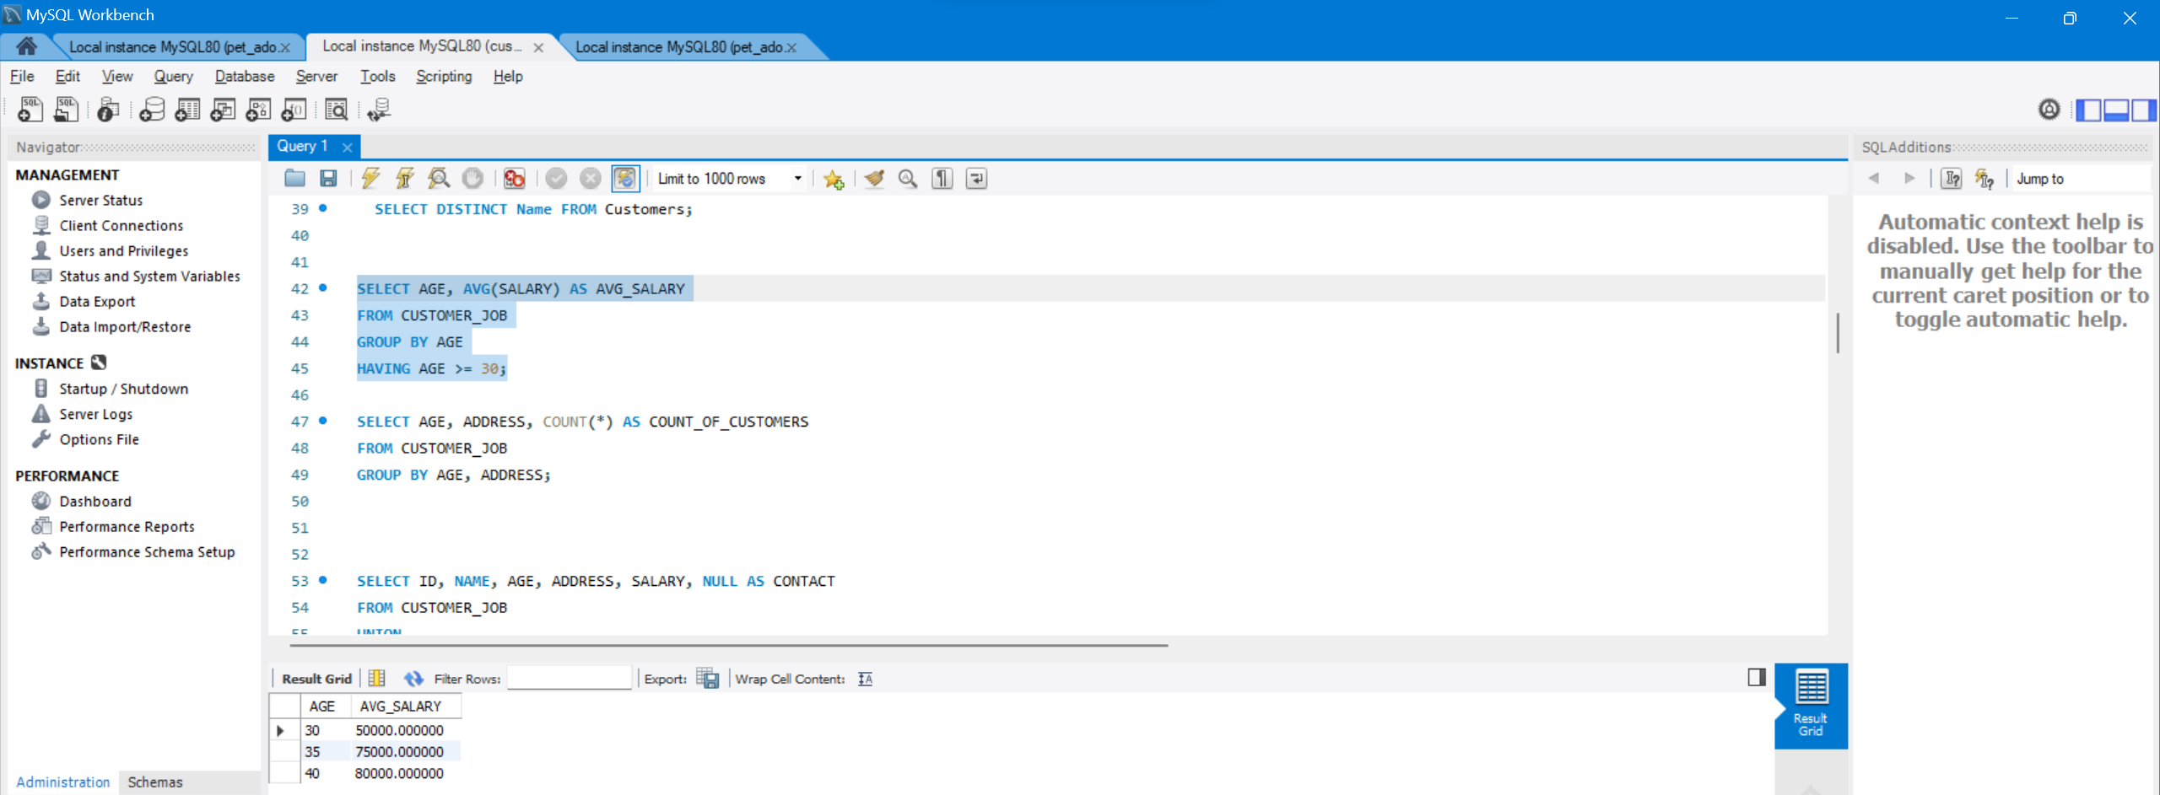

### Group By Clause :

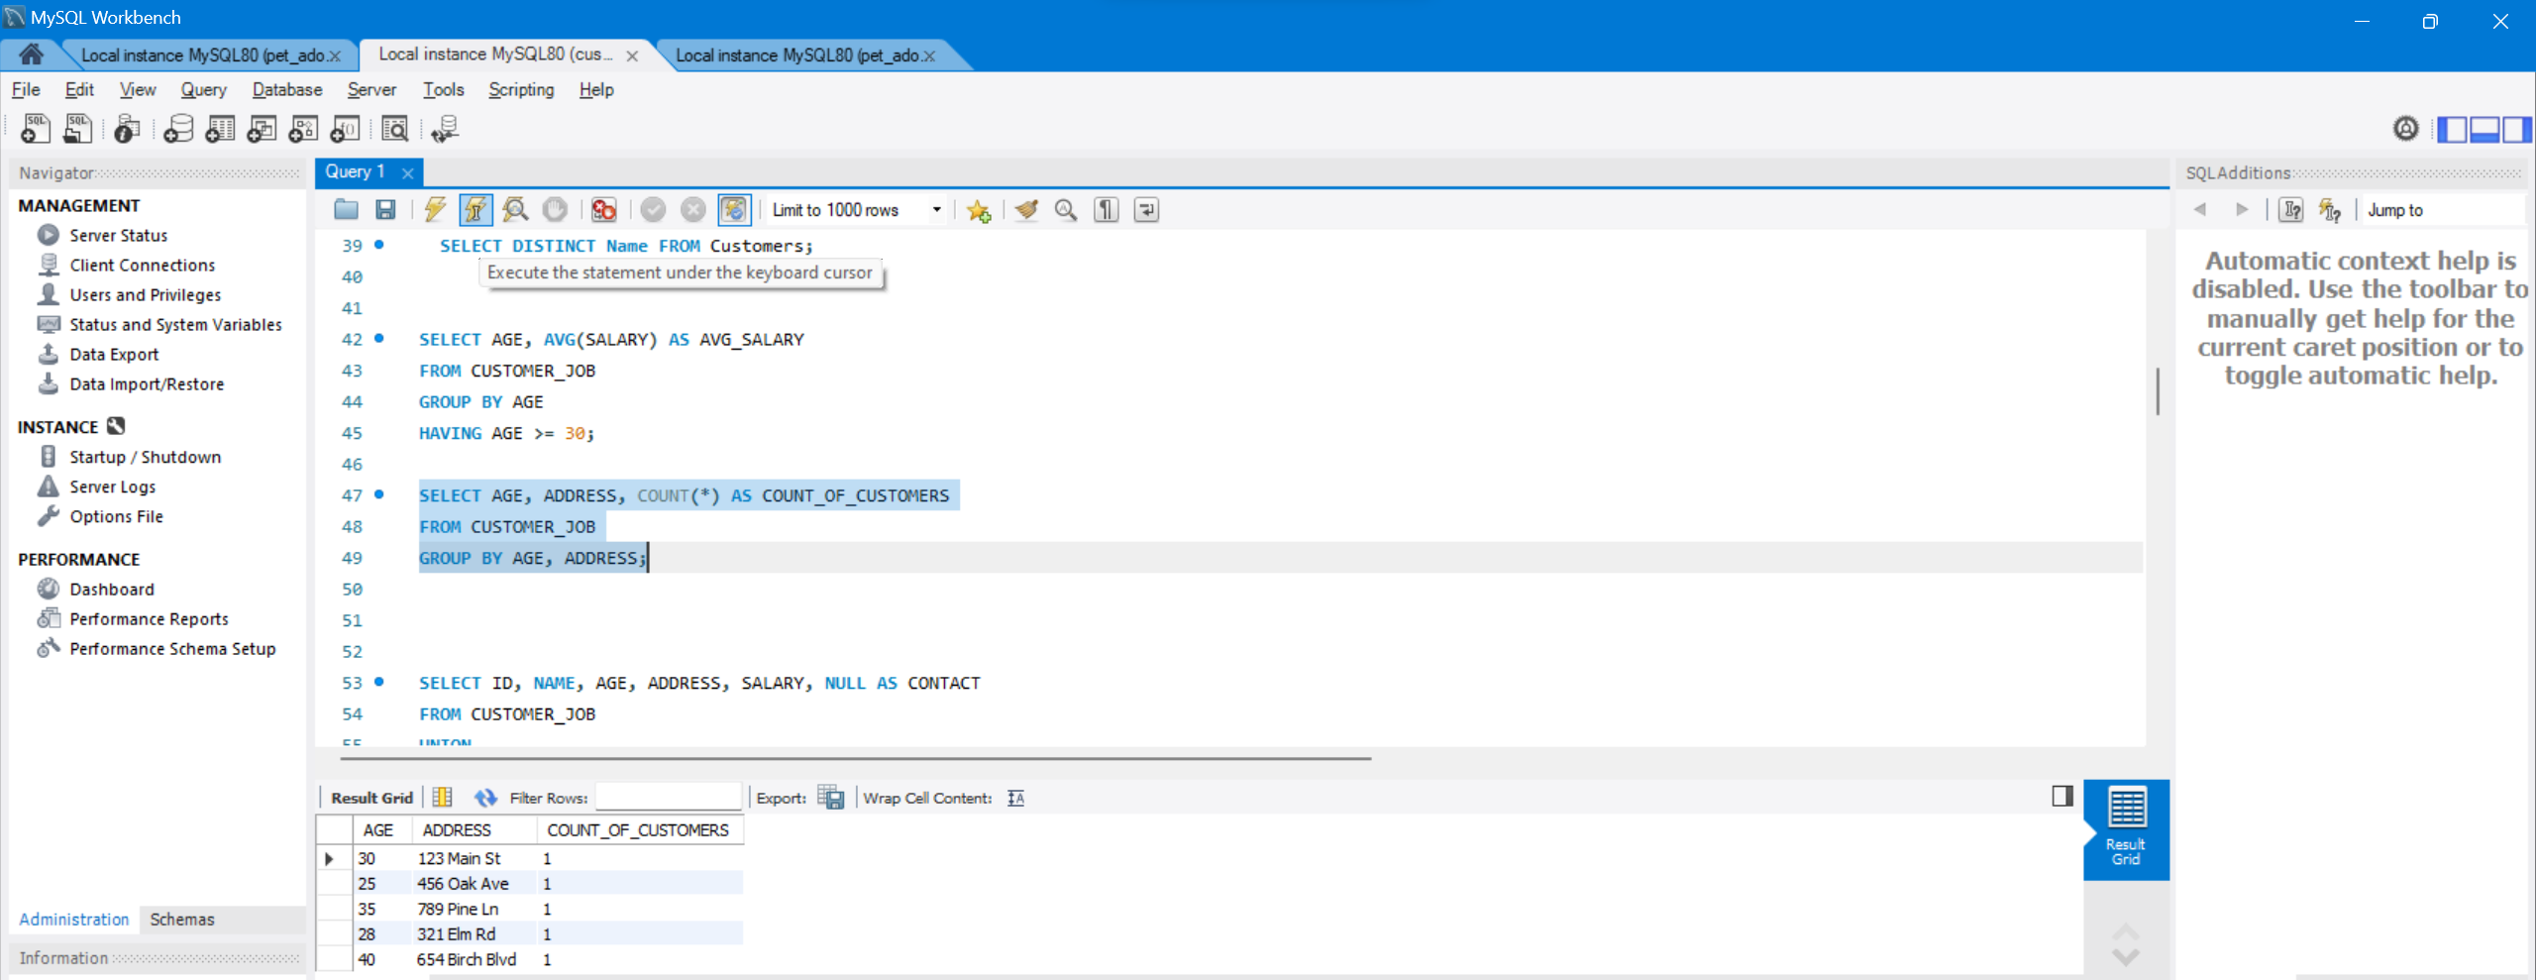

# **SET Operators in SQL**

SET operators are special type of operators which are used to *combine the result of two queries.*

Operators covered under SET operators are:

1. **UNION**
2. **UNION ALL**
3. **INTERSECT**
4. **MINUS**

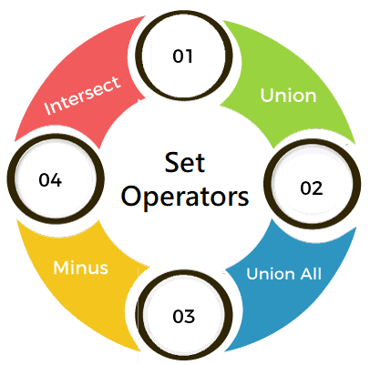

**Table 1: t_employees**

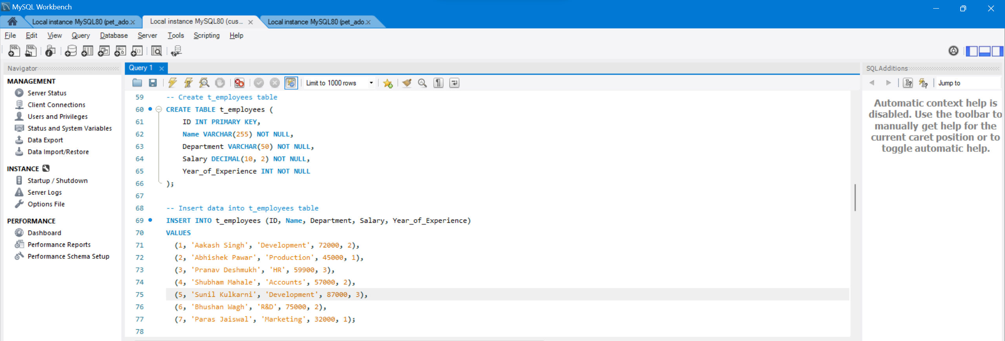

**Table 2: t2_employees**

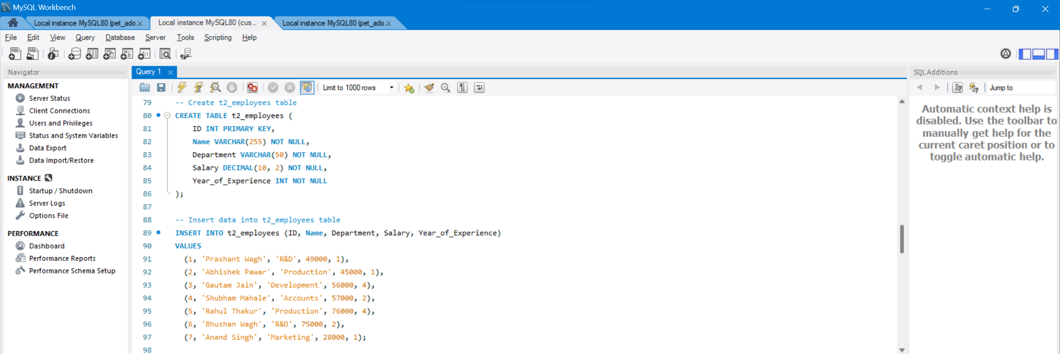

**Table 3: t_students**

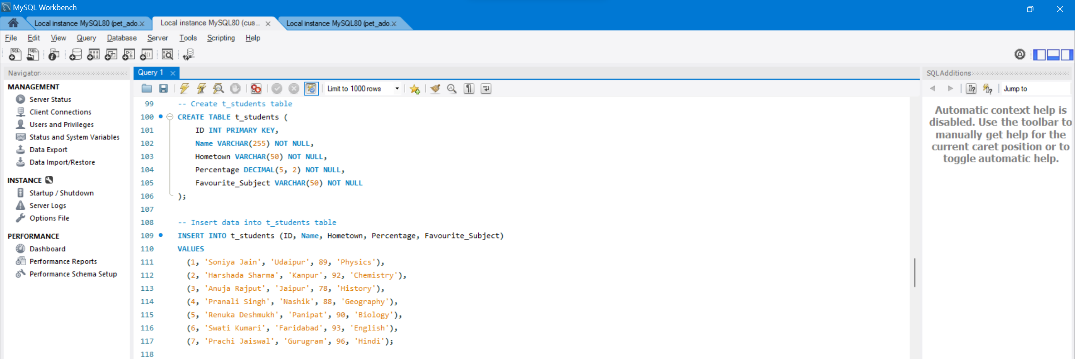

**Table 4: t2_students**

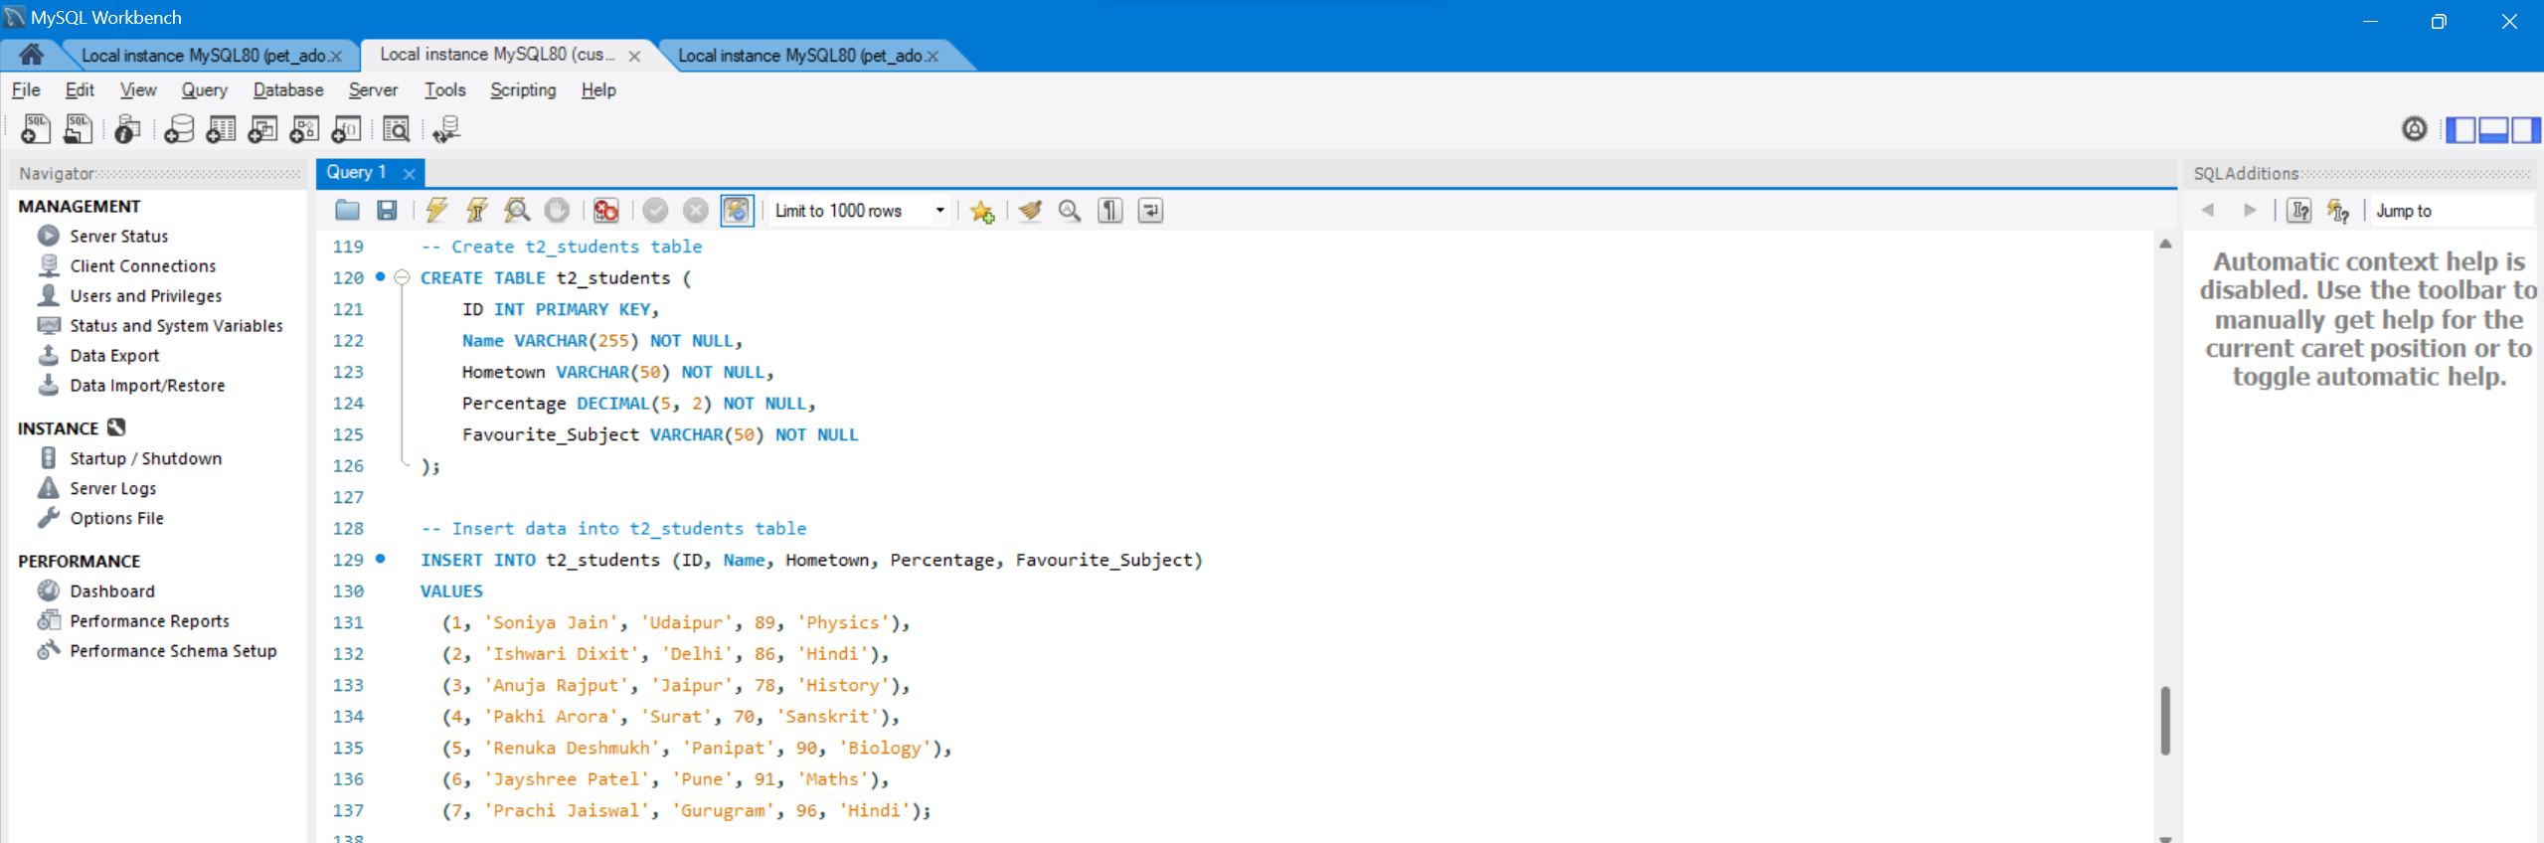

## 1. UNION:

1. mysql> **SELECT** \***FROM** t_employees **UNION** **SELECT** \***FROM** t2_employees;

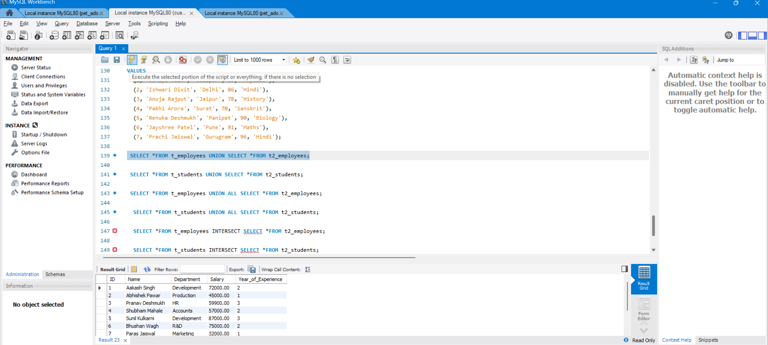

**Example 2:**

1. mysql> **SELECT** \***FROM** t_students **UNION** **SELECT** \***FROM** t2_students;

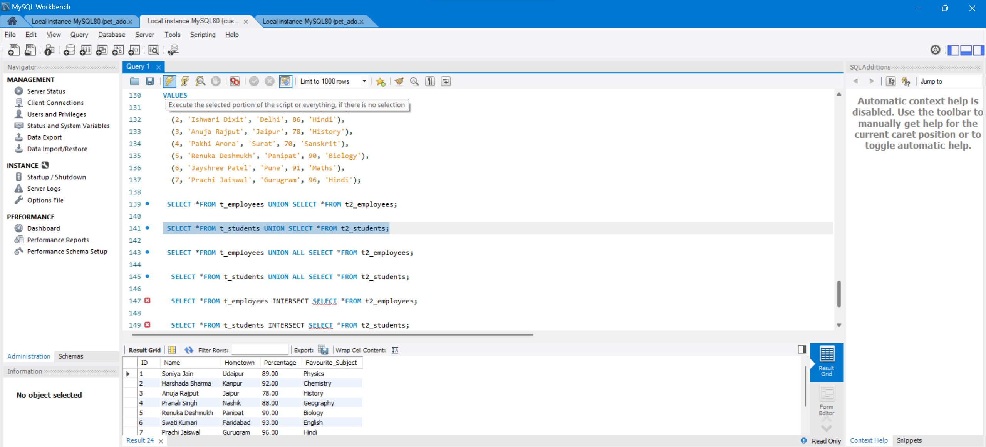

## 2. UNION ALL

**Query:**

1. mysql> **SELECT** \***FROM** t_employees **UNION** ALL **SELECT** \***FROM** t2_employees;

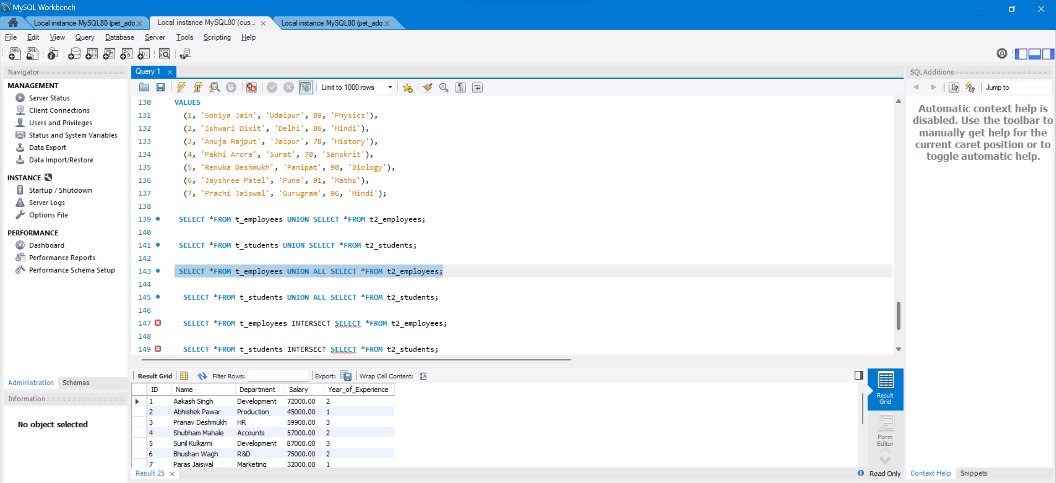

**Example 2:**

1. mysql> **SELECT** \***FROM** t_students **UNION** ALL **SELECT** \***FROM** t2_students;

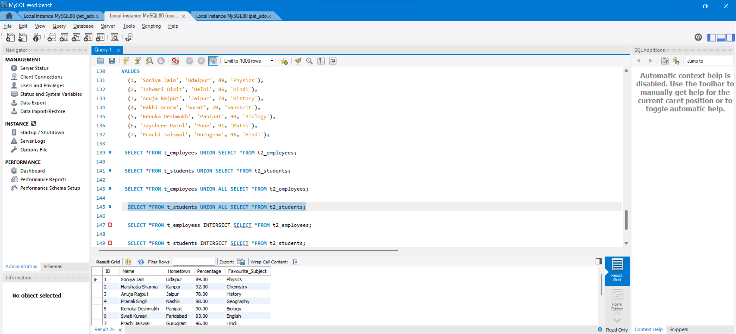

3. INTERSECT:

1. mysql> **SELECT** \***FROM** t_employees **INTERSECT** **SELECT** \***FROM** t2_employees;

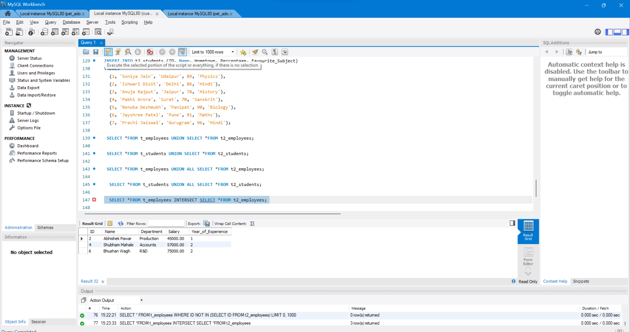

4. MINUS:

1. mysql> **SELECT** \***FROM** t_employees MINUS **SELECT** \***FROM** t2_employees;

